Asia-China-Coin-Spade-Flat Handle-Arched Foot-400-300 BCE-H 3.39 R 3

虞一釿Yú yī Jīn (Yu one jin), 6.5 cm. / 2.60 in., width: 3.8 cm. / 1.50 in., DCD 222, FD 295, H 3.39 R 3

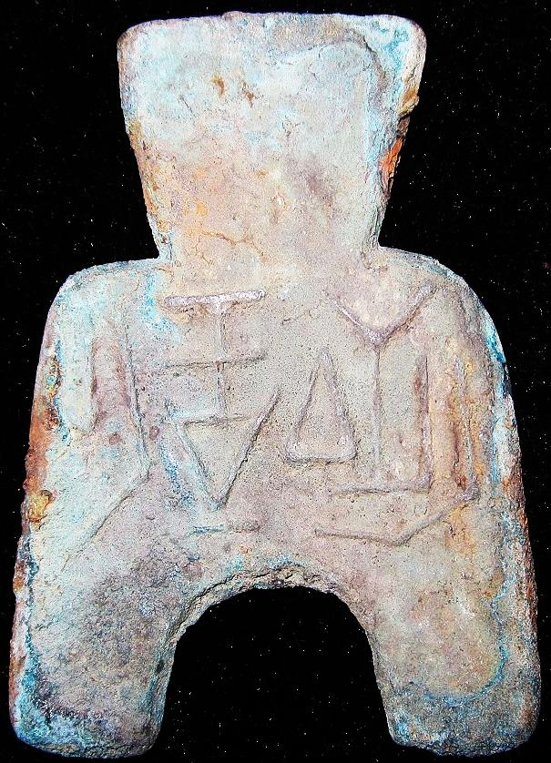

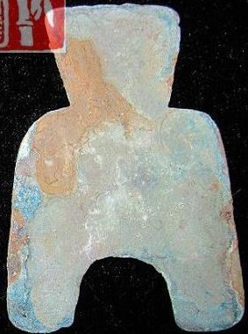

Order details Printer friendly page

Sold by

[bcculture](http://myworld.ebay.com/bcculture) ( [81](http://feedback.ebay.com/ws/eBayISAPI.dll?ViewFeedback&userid=bcculture)  )

+ Show additional actions

Delivery package 1 of 1

Estimated delivery Friday, Jan 17, 2014 - Wednesday, Feb 5, 2014

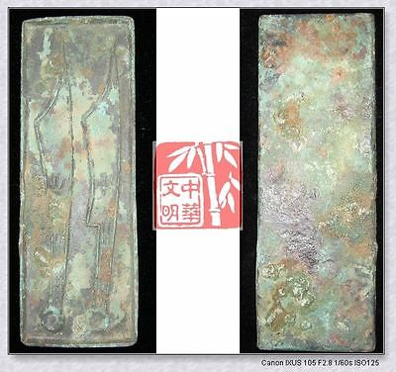

[WARRINGSTATESPERIOD YAN NATION MINT MONEY MODEL BRONZE FALCION COIN PATTERN针首刀6"](http://www.ebay.com/itm/251391538342)

Item price

$79.99

Quantity

1

Item number

251391538342

Shipping service

Economy Shipping from outside US

[Leave feedback](http://feedback.ebay.com/ws/eBayISAPI.dll?LeaveFeedbackShow&useridfrom=802-867&useridto=bcculture&item=251391538342&transactid=1360128554015) [Contact seller](http://contact.ebay.com/ws/eBayISAPI.dll?FindAnswers&frm=3998&iid=251391538342&redirect=0&requested=bcculture) [Return item](http://return.ebay.com/ws/eBayISAPI.dll?ResolveReturn&eventName=viewSelectedItem&TransactionId=1360128554015&ItemId=251391538342)

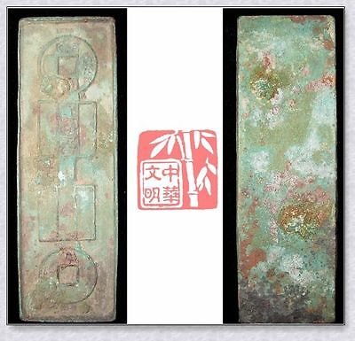

[VINTAGE HAN XINMANG TIME ￥10000 MONEY MODEL BRONZE FALCHION COIN PATTERN国宝金匮直万6"](http://www.ebay.com/itm/251396289678)

Item price

$69.99

Quantity

1

Item number

251396289678

Shipping service

Economy Shipping from outside US

[Leave feedback](http://feedback.ebay.com/ws/eBayISAPI.dll?LeaveFeedbackShow&useridfrom=802-867&useridto=bcculture&item=251396289678&transactid=1360163231015) [Contact seller](http://contact.ebay.com/ws/eBayISAPI.dll?FindAnswers&frm=3998&iid=251396289678&redirect=0&requested=bcculture) [Return item](http://return.ebay.com/ws/eBayISAPI.dll?ResolveReturn&eventName=viewSelectedItem&TransactionId=1360163231015&ItemId=251396289678)

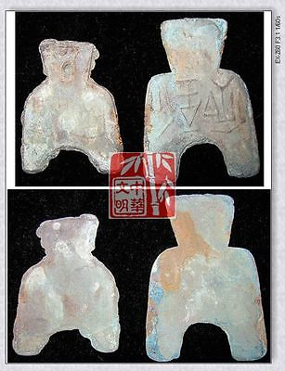

[WarringStatesPeriod WEI NATION CAPITAL MINT WEIGHT MONEY BRONZE SPADE COIN虞*釿SET](http://www.ebay.com/itm/251413448140)

Item price

$69.99

Quantity

1

Item number

251413448140

Shipping service

Economy Shipping from outside US

[Leave feedback](http://feedback.ebay.com/ws/eBayISAPI.dll?LeaveFeedbackShow&useridfrom=802-867&useridto=bcculture&item=251413448140&transactid=1360205391015) [Contact seller](http://contact.ebay.com/ws/eBayISAPI.dll?FindAnswers&frm=3998&iid=251413448140&redirect=0&requested=bcculture) [Return item](http://return.ebay.com/ws/eBayISAPI.dll?ResolveReturn&eventName=viewSelectedItem&TransactionId=1360205391015&ItemId=251413448140)

### Shipping address

Ralph J Coffman Jr  
149 Atlantic Ave   
Swampscott MA 01907-2427  
United States

Phone number  
781 584 7091

### Order total

Subtotal $219.97

Shipping $80.00

Discount -$15.00

#### Total

## $284.97

[View PayPal transaction](http://payments.ebay.com/ws1/eBayISAPI.dll?IntermediateResolutionInfo&itemid=0&transId=0&pn=UnifiedCheckoutSummaryRedirect2PP&qs=itemid%3D0%26transId%3D0%26buyerorseller%3D0%26)

### Order information

Order placed on  
Sunday, Dec 29, 2013

Having a problem with this purchase?  
[Resolve problem](http://res.ebay.com/ws/eBayISAPI.dll?ResolutionCenter)

Payment method   
PayPal

Payment date  
Sunday, Dec 29, 2013